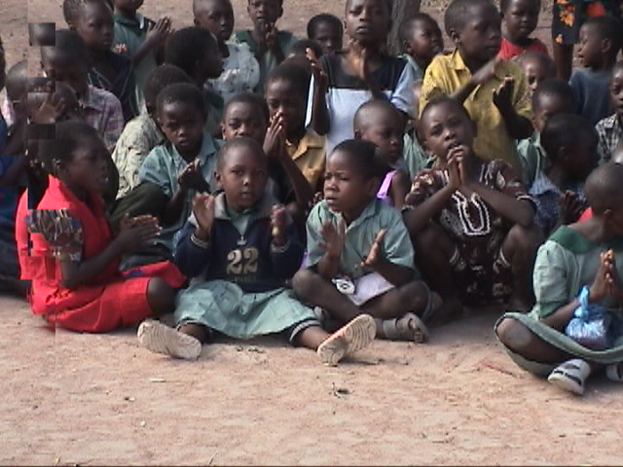
Can a picture say a thousand words?

Maybe many more!

This little fellow is among one hundred orphans and children from very poor households cared for by the people of Igondola Parish (St. John’s), our local Parish Church. Presently the ministry is conducted under the title

Igondola Evangelist Groups.

This is a remarkable ministry. Yes, there are many, many thousands of children cared for in Africa through Compassion International, etc but this is a ‘congregation based’ ministry. It is heart warming to see the devotion of the people to these children. However they have given about as much as they are able in material things – including food. There comes a point at which the burden is truly greater than the local resources can manage. Most orphans are the result of parents dying of AIDS or malaria. In this area it is most probably malaria. Poverty in households is a symptom of a father dying or deserting the family.

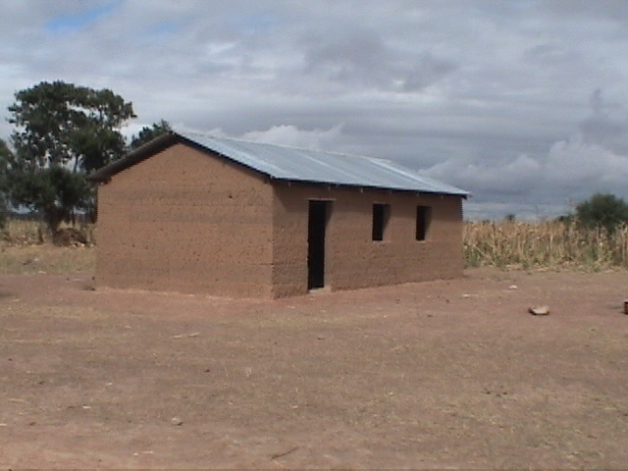
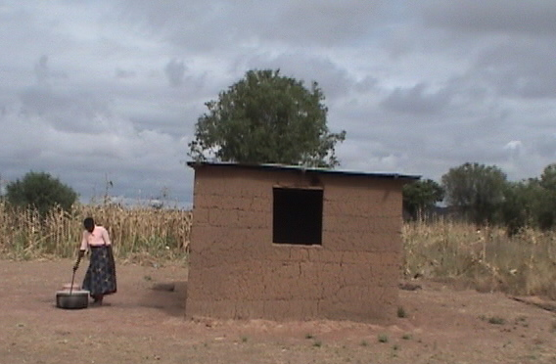
The congregation has appealed to me and to the Amani Ministry to assist with the care of the children. They will do all that they can – provide the cooks for food, the committee to manage the program, the homes to house the orphans, the men to construct buildings and the women to care and love each child. But they need assistance. The partly completed building at the left has been erected with donations from Australia as has the small store/office to the right. They urgently need a ‘cookhouse’ and an improved toilet. Yes, it is all quite basic – but it works! Children are loved and encouraged in their education.

I participated in a committee meeting several weeks ago and am now a member of the committee. Through donations presently gathered in Australia I was able to assure them that Amani will supply the sugar for their porridge ($40.00AUS per month); the wages for the teachers ($20.00AUS per month; and give some assistance with uniforms. These are the uniforms they need for Primary School and also for attendance at this ‘Children’s Ministry’. Here uniforms put every child on an equal level and they feel like ‘somebody’! I have pledged to supply the maize for the porridge through the Food Relief Program. That will require two large sacks of maize per month – about $36.00US. Uniforms for children cost at $3.00AUS per child
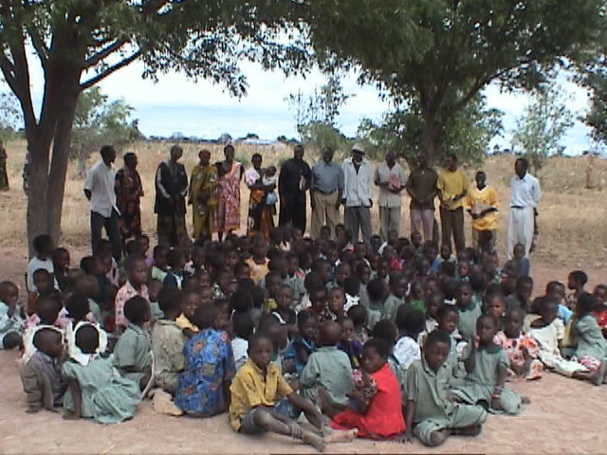
There are other costs such as medical care but these are the occasional costs. The great need at this time is to complete the two partly completed buildings and to erect the ‘cookhouse’ and toilet before the wet season arrives in early December. To complete the present two buildings we need about $250.00US for timber (windows and doors) and fifteen sacks of cement ($12.50US per sack). The work is done by volunteers. The photograph to the left shows some of the children with committee members gathered in the background.
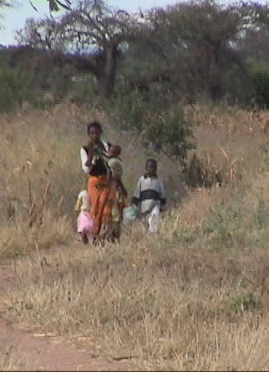
This is how the children arrive at the Church. The young mother is bringing two of her own and also one little orphan who are in her care. It was wonderful to see these small children walk up to the group and take their place very peacefully with the other children. It is a place of ‘belonging’ and a ‘safe’ place.

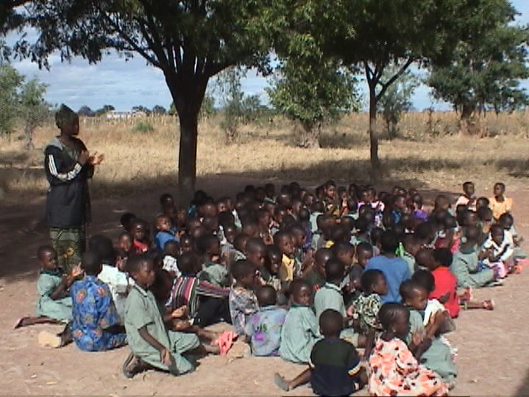
As I watched the children I could see that for most of them the designation ‘orphan’ disappeared as they participated in the larger group. Well, that seemed true for most but I was struck by one young fellow who ‘did it all’ but there was never a smile! He looked at me and nodded his head – but there was no smile! African children smile and laugh! He is the lad in the grey ‘suit’ in the foreground. You remember such a child!

We do have yet to consider the name for this Ministry with Children. Compassion International was offering some assistance but that has not continued so it will be a combined St. John’s – Amani Ministry. One very simple thing we can provide from the Center is ‘greens’ for their meal time. Chinese cabbage literally ‘grows like grass’ here and is very popular. Presently they have only ugali porridge.

Do pray for the children, their ‘home family’ and the teachers.
Pray for the Committee as they oversee the ministry and do their best to see that the urgent needs are met.
Pray for us all as we work on the program so that it will be both instructive and joyful.
Pray that hearts will be touched by the need and that offerings will be made to support the work.
Pray for the Amani Center as we seek to ‘make a difference’ in the communities amongst which we live.

(This Sunday, June 16th, I am to drive with seven others to the Rift Valley (four hours of ‘local roads’) to preach and to encourage the gathering at a village Church. They expect about 600 adults and 300 children to gather from several nearby villages. It promises to be a
l-o-n-g day but also a very fulfilling day.)

Every blessing.

John Naumann,
Amani Development Center.
(See the May Report for donation advice)

