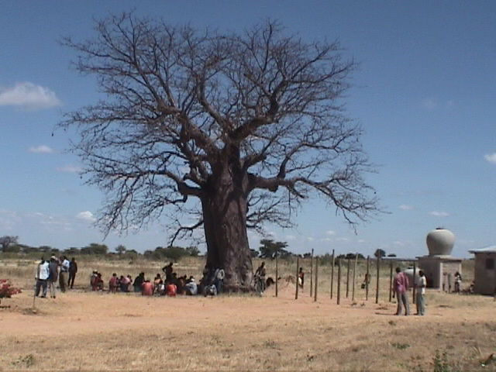

CommunityRelations


The Amani development Organization is a ‘Christ Centered, Community Related’ ministry. This means that Faith and Service must touch upon every activity. It would surely be easier if we simply ‘closed the gate’ and concentrated on development on the Amani land and the planning of the school but then we would not be true to our calling.

Assistance through Work Opportunity
Apart from our normal work force we have up to eighteen people each week, mostly women, working to raise finance for a variety of family needs. It is significant that no one comes and simply asks for money! All ask to work for funds to support family needs. However this severely strains the budget. We pay 10,000/= per week (Almost exactly $10.00 AUST.). People normally work for a three week period. The ‘needs’ cover medical expenses, secondary school fees, house repairs resulting from the severe rains,, etc. I often average three requests per day. People need to come with evidence of need in the form of a document from a doctor, hospital, school or Village Committee. In the photograph we see some of the ‘Work Assistance’ people gathered under the tree at the well.

Presently we have:
Mary Nasi Her child was born with a ‘floopy foot’ and needs hospital attention.
Joffrey Matonya A child with TB who needs to have care at Dar es salaam.
Andrew Petre His child needs secondary school fees.

I offer these as representative of the needs which come to our attention. In this poor nation there really is no ‘safety net’ for the people in the villages. Our hope is to offer assistance while we also work to life the living standard of the people. The annual cost of this aspect of our ministry is about $6,500.00 per year. I would like to institute Operation Compassion, a program focused on these areas of need. It is this aspect of ministry which has gained for Amani the reputation of kindness. People are used to being brushed aside by ‘officials’. Others who do truly care do not have the resources to express their concern. We do have the opportunity to touch the lives of very many people, especially the young mothers and children and the elderly. Maybe there is a community of people, like the people of the Lockyer Valley, who would see in this an opportunity to share God’s love. I pray so. At this point I express thanks to the people who assisted with the Power and Water Crisis. All is now ‘well’!

Presently I am speaking with a wonderful woman in Dodoma about ‘Women’s Needs’ in the region. We do have a partly completed ‘foundation’ here which I hope one day will be the foundation of the first stage of a Women’s Vocational Training Center. It is near the well, the new public toilet and the developing ‘shelter’ for workers and other gatherings. It will be an attractive setting. All is adjacent to the large Center Cross. It will cost about $9,000.00US to complete the basic building to a good standard, using our building team. It may be that there is a person or group ‘out there’ who have a keen interest in Women’s Vocational Development. This would be a wonderful project to support, knowing that we have an excellent and experienced resource in my friend, Mrs. Kassembe. Presently she is employed by the Anglican Province of Tanzania. Of course there are many other aspects of ‘community involvement’. In another message I shall highlight another which is our close involvement with the orphans and children from very poor families who gather at St. John’s Church, Makang’wa.

John Naumann, Amani Development Organization.

