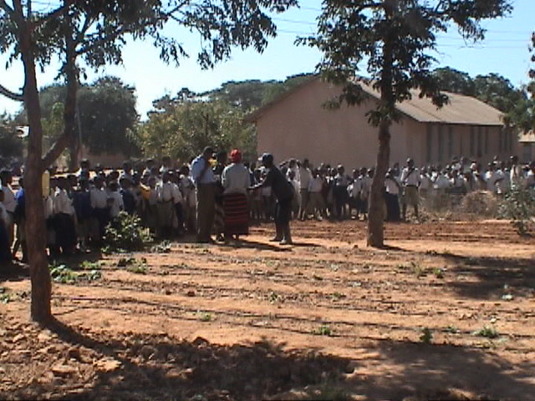

Drip Irrigation & School Nutrition Program


This area of activity has ‘caught fire’. People have now seen the benefits and are keen to develop gardens of their own. The photograph to the right is from Mvumi Makulu Primary School. They have harvested the vegetables and have then greatly expanded there area of their garden. They will plant in early July following the school holiday break.

All schools are expanding their garden areas. A new system is being established at a local Compassion International Center (270 orphans and children from very poor families). A large new garden is also being established at the Mvumi Mission Secondary School. The school projects do provide food and they also provide excellent exposure to the systems for the children, teachers and parents.

Our present Facilitator, Godson Magawa, has gained a scholarship to study for a Master’s Degree at Vassar University Finland. This is a great achievement. I do believe that he understands that the climate will be different! We now have to train a new Facilitator. I believe that we have identified that person. He is now working with Godson and will be further trained by my brother-in-law when he is here this year.

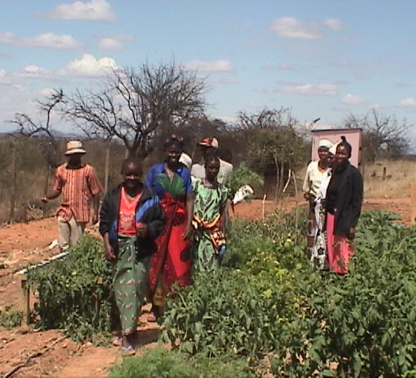
Last year contact was made with a group of AIDS survivors/supporters. These people are now ready to commence a large garden project at Mvumi Mission. We shall provide the kits and the expertise to assist them to develop an excellent garden. Their aim is to provide good food for their own needs and to have produce to sell for family income. In the photograph we see Godson Magawa with some of the group members when they came to see the house garden.

We are also in the early stage of planning a Garden Project with a group of single mothers. The plan is to give them use of a plot on our Center (We have unused land) for about two years to ‘model’ what is possible. We have water available. The women would be expected to work at the Center for three half days as their response to the gift of water but also to give them further experience in the operation and maintenance of the Drip System. With about twenty kits they would be able to provide a good quantity of food, year around. I am sure that other small cooperatives would form.
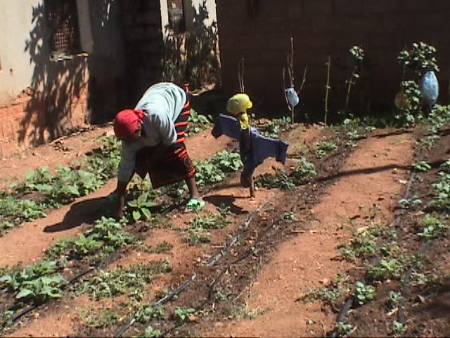
Here we see a ‘private’ garden in the home of a doctor at the Mvumi Mission Hospital. They have harvested lots of ‘greens’ and are keen promoters of the system. Note the scarecrow! The birds also look for greens in the dry season! We are very thankful to the community of Lockyer Valley for their support of the School Nutrition Program. Thank you. Keep up the good work as it is providing a wonderful blessing in these communities. I pray that some other communities may come to adopt an aspect of the work here.

With thanksgiving,
John Naumann, managing Director,
Amani Development Organization.

