 The Sponsorship File

In the past we have managed to sponsor many students through High School and through College Degrees or Diploma Studies. We are changing this system to a ‘sponsorship program’. I shall simply advertise the names and some details of students requiring sponsorship and ask those reading this posting to consider the need and also to pass this on to anyone who you consider may have an interest in supporting education. I know all of the following people personally. All have been interviewed and all come with recommendations from schools and from pastors.

+ + + + + + + + + + + + + + + +

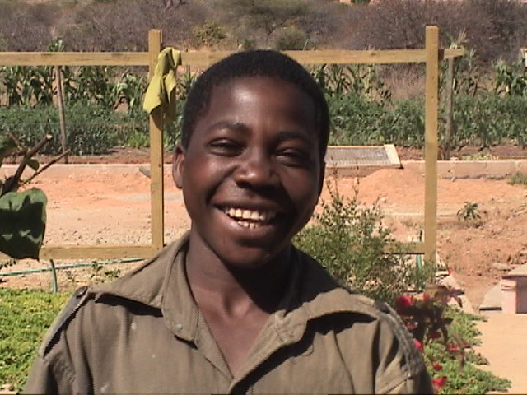
Albert Keneth Ng’hambi is a student attending Mvumi Makulu Secondary School. His father is ‘away’. His mother struggles to make ends meet and to keep the children in school. Kenneth has come to the Center seeking assistance. He is currently working to raise some funds for his schooling. He comes with high recommendation from the Headmistress of his school. I do know her personally. The following is an overview of his work: Civics C; History A; Geography A; Kiswahili B; English B; Physics A; Chemistry A; Biology A; Mathematics B.
Albert is typical of many young people needing sponsorship. The school fee is $40.00AUS per year. In addition each family is asked to contribute $8.00AUS per year towards the cost of building the new Secondary School. The fees mentioned are the very ‘basics’. If you can sponsor Albert (or one of the many other ‘Alberts’ in the surrounding communities) do send donations to the addresses indicated on the May Report. The fee should be here by early July.

+ + + + + + + + + + + + + + + + + +


Jackson Lazalo Malyosi is a member of the congregation at the Anglican Church at Mloda Village, to the south of Makang’wa. I preached there several weeks ago and have been through Mloda a number of times. I have a developing relationship with the congregation. Jackson is seeking support in his intention to train as a catechist for his community. The ‘catechists’ are the teachers and ‘local pastors’ of the congregations. He is a fine young man. The basic cost for training at the Bishop Madinda Matumbulu Christian Formation Centre (conducted by the Anglican Church in a rural setting – Basic!) is $200.00AUS per year. The course is a two year course. At this Center students must bring a bucket, hoe, plates, etc plus all of their study/writing materials. Therefore a little extra would not be unappreciated! Send sponsorship gifts to the address mentioned in the May report.

+ + + + + + + + + + + + + + + + + + +
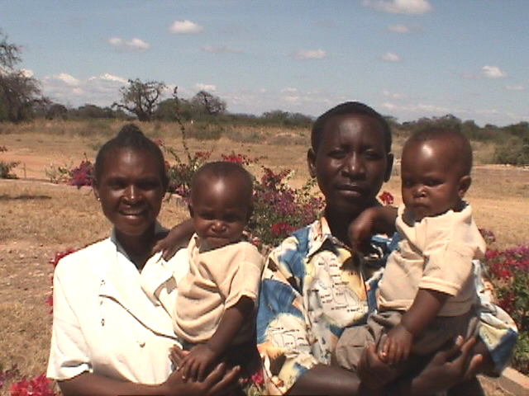
Julius Mgongo and ‘Mama watoto’ . In Tanzania the custom is to identify a woman by her child or children. The children are twins! However this couple have also two children in Secondary School. They are from the Parish of Mloa Barabarani, again to the south of here. Mama watoto desires to attend Msalato Bible College to study a three year course. She will then be a pastor serving in a congregation. The cost is $350.00AUS per year. Once again, this is the basic cost. A little more would be most helpful. This family comes with high recommendation.

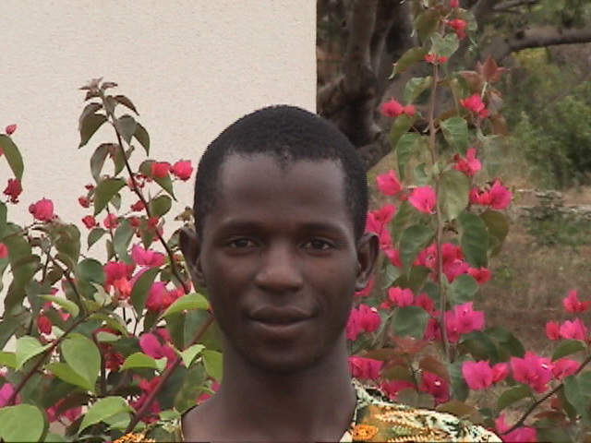
James Erick Yonah is a member of St. Andrew’s Church, Makang’wa. James has worked at the Amani Center. He is a keen young man and highly recommended by his pastor and myself. He is 22 years of age. For his hobby he wrote: studies hard – and then added soccer! He desires to study Electrical Engineering at the Technical College, Arusha. This is a three year course. He has gained Government Sponsorship. That means he has done well at High School. The basic cost is $167.00AUS per year. I would suggest a sponsorship of $200.00 per year. He will no doubt want to travel home for the major holidays. Arusha is a long way from Makang’wa. Private students have to pay about $767.00 per year! James has done very well. Fees are due before the end of July.

+ + + + + + + + + + + + + + + + +

Pamela Kalula. Pamela is a student at the Mvumi Hospital Laboratory Training School. She is in the first year. The annual fee is $460.00AUS. Pamela has managed to pay $300.00AUS but has failed to raise the remainder. She has been sent home to collect the remaining fees! That will be a difficult task. I have received a letter from the Principal of the School asking for any assistance we can provide. I do not have a photograph of Pamela as home is not nearby. I am very familiar with the Mvumi Hospital School. Recently I was Guest of Honor at the Graduation Ceremony of students who are members of the Student Christian Association at the Hospital. It was a great ‘celebration’ of the dedication of these young men and women. This is an urgent need.

+ + + + + + + + + + + + + + + + + + + + +

Sponsorship of these students will be greatly appreciated. All are fine people and come highly recommended.

I understand that there are many areas of need indicated in the attachments to the May Report. I have used this ‘attachment’ method to highlight areas on ministry and areas in need of support. Each ‘need’ is an opportunity to positively impact the lives of many people. Here in Tanzania we are in a ‘holiday or vacation’ time. I am a little late in getting this material out owing to the VIRUS which has caused havoc in the region. In fact as I type this I pray that all will go well tomorrow at the Internet Café.

My laptop computer is ‘down and out’ at present. I hope that it can be restored when I visit Billings in September/October.

Every blessing.

John Naumann

